Abstract
Air ventilators are now used in almost every industries and institutions for the evacuation of heat and humidity to the atmosphere so as to circulate inner hot air and maintain the temperature. Air ventilators have various benefits like improved air quality, energy savings, and reduction of greenhouse gases emissions. The main aim of our project is to generate electricity with this design and use clean energy (wind) and solar as the source of electricity generation by using rooftop air ventilator and solar panels. When the air ventilator rotates the flux of the permanent magnet rotor part is moving across the air gap and induces a.c. voltage in the single phase stator winding. Further the generated output will be rectified to d.c. voltage. Therefore serving two purposes at the same time i.e. ventilation as well as electricity generation. Energy conservation and exploration of new energy avenues are the well accepted solution to fulfill the growing industrial demand in future. Thus the project aims at utilizing clean energy for electricity generation with the help of air ventilators and solar panels, also as the ventilator works throughout the day i.e. day and night, therefore holding a great importance with collaboration of solar.

CONTENTS

Chapter1. Introduction
1.1 Energy scenario in India
Chapter2. Block diagram & working (Air-ventilator & solar panel)
2.1 Block diagram of project
2.2 Working
2.2.1 Air ventilator
2.2.2 Solar
Chapter 3 Block diagram and working of electronic monitoring circuitry
3.1 Detailed block diagram of electronic circuitry
3.2 Working of electronic monitoring circuitry
Chapter 4 Components used (Air ventilator)
4.1 Air ventilator
4.2 Pancake type generator
4.2.1 PM disk or rotor
4.2.2 Stator
4.3 Rectifier
4.4 Dc appliances
Chapter 5 Components used (solar panels)
5.1 Solar panels
5.2 Solar charge controller
5.3 Battery
5.4 inverter
5.5 AC load
Chapter 6 Components used in electronic controller circuitry
6.1 Arduino uno
6.2 Temp sensor
6.3 Ir sensor or tachometer
6.4 Voltage sensor
6.5 Current sensor
6.6 Lcd(liquid crystal display) 16*2
6.7 Arduino software
Chapter 7 Advantages & applications
Chapter 8 Future scope
9 conclusion
10 reference

List of figures

S.no | Title of figures
1 | Energy scenario in India
2 | Block diagram of project
3 | Induced Emf
4 | Working diagram of air ventilator
5 | Solar panel & battery arrangement
6 | Block diagram
7 | Air ventilator
8 | Top view of generator
9 | Side view of generator
10 | Bottom view of generator
11 | Rotor
12 | Stator
13 | Full bridge rectifier
14 | Led bulb
15 | Led array
16 | Actual image of 190 Watt solar panels
17 | Solar connections in parallel
18 | Solar charge controller each of 6Amp
19 | 12V, 80Ah battery
20 | 900VA inverter
21 | Detailed diagram of arduino
22 | Arduino Uno
23 | Tachometer
24 | IR sensor as tachometer
25 | Voltage sensor working
26 | Voltage sensor
27 | Current sensor
28 | Lcd display

List of tables

S.no. | Table name
1 | Ventilator modified specification
2 | Generator detailed specification
3 | Rotor specification
4 | Stator specification
5 | Solar connection voltage and current details
6 | Technical specifications(Arduino)
Chapter 1: Introduction

Wind power is the conversion of wind energy into more useful forms, such as electricity. Most modern wind power is generated in the form of electricity by converting the rotation of turbine blades into electrical current by means of an electrical generator. Wind energy is considered to be a very clean, cheap and important renewable energy source particularly for rural areas, farms, remote on- shore and off-shore installation away from main electrical grid. It is easy to produce electricity because it is a natural resource which can be used freely and fuels become more expensive.

Axial-flux permanent magnet (AFPM) machines have become an important subject of study because of the development of neodymium magnets over the past 20 years. These machines offer many unique features. They are usually more efficient because of the fact that field excitation losses are eliminated resulting in significant rotor loss reduction. Thus, this machine efficiency is greatly improved and higher power density is achieved.PM machine advantages include lightweight, small size, simple mechanical construction, easy maintenance, good reliability, high efficiency, and absence of moving contacts. ^{[1]}

The solar ,wind, water, ocean waves can play important role in production of electricity .But the some problems arises in the development of energy power generation like, high construction cost, difficulties in maintenance, space for plant installation and power distribution. The India is in the tropical zone. There is high humidity and warm weather present in all of year. Specially march, April, may . Because of high intensity of sunlight and high room temperature the ventilation is necessary in workshop’s, industries or factory building .Therefore the rooftop ventilator’s are used for ventilation purpose because this ventilator are work on without using electric energy. This technology is popularly installed on the roof in workshop’s, industrial buildings, ware houses and also in residences. The main function of this ventilator is that when the air flow on the top of roof or the hot air that lifting under the roof that called ventilator. The ventilator suck the hot air from building and through outside the building and maintain the building temperature. The function of roof top ventilator is to convert wind’s kinetic energy to electrical energy. ^{[2}

1.1 Energy scenario in India

Energy is the major source for the economic development of any country. In case of the developing country like India, shortage of electricity work as a barrier for development. In recent years, India׳s energy consumption has been increasing at a relatively fast rate due to population growth and economic development. Rapid growth of the Indian economy places heavy demand of electric power. Presently most of the electric demand fulfilled by coal power plants and creates pressure on fossils fuel. Coal-based power generation is characterized by local and regional environmental degradation as well as greenhouse gas emissions, leading to climate change. Thus, there is need of enhance energy security along with reducing greenhouse gas emissions. Renewable energy is one of the environmentally friendly sources of energy. In present energy scenario harnessing of renewable potential in effective manner is becoming need of the era, which can provide sustainable power supply as well as mitigate the negative environmental impact due to fossil fuel. ^{[5]}

The utility electricity sector in India had an installed capacity of 307.28 GW as of 31 October 2016. Renewable power plants constituted 28.9% of total installed capacity. India's electricity sector consumes about 72% of the coal produced in the country. The high ash content in India's coal affects the thermal power plant's potential emissions. Therefore, India's Ministry of Environment and Forests has mandated the use of beneficiated coals whose ash content has been reduced to 34% (or lower) in power plants in urban, ecologically sensitive and other critically polluted areas, and ecologically sensitive areas. ^{[4]}

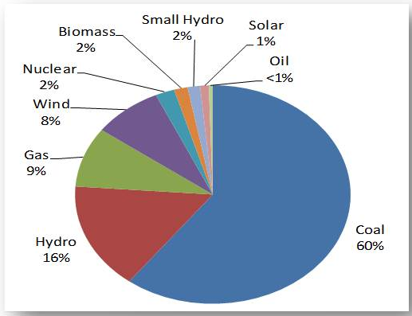

Figure1. Energy scenario in India

India's renewable energy sector is amongst the world's most active players in renewable energy utilization, especially solar and wind electricity generation. As of June 2016, India had grid connected installed capacity of about 42.85 GW non-conventional renewable technologies-based electricity capacity, about 14.15% of its total; exceeding the capacity of hydroelectric power for the first time in history.

As it is very much clear from figure 1 that renewable energy accounts only for about 28% in total energy scenario therefore it is the urge that we should move more towards renewable energy for a better tomorrow.

Chapter 2. Block diagram & working (Air ventilator & solar panel)

About project: The project aims to generate electricity with the help of rooftop air ventilator and solar panels. The main backbone of the project relies behind using renewable and sustainable source of energy. The rooftop air ventilator which is used to exhaust hot air is here used to generate electricity by mounting a pancake type generator on the base and serve both the purpose i.e. ventilation and generation and finally charge the battery and with this we have also clubbed 190Watt of solar panels. The detailed information is further explained with the help of block diagram.

2.1 Block Diagram of project:

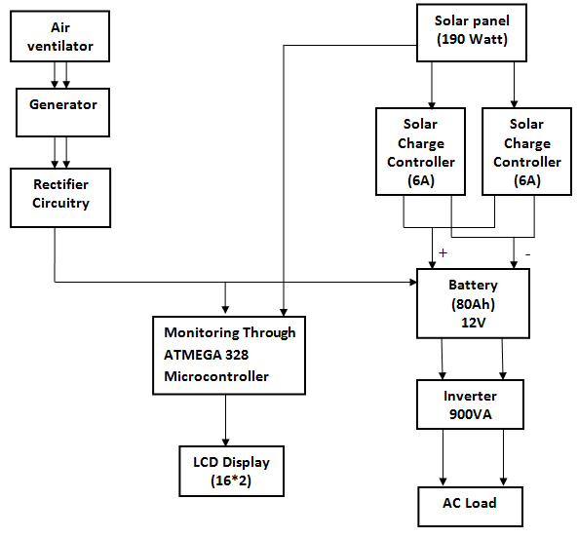

Figure2. Block Diagram of project

2.2 Working:

2.2.1 Air ventilator:
Electricity generation by air ventilator include air ventilator, generator, power converter’s & load.

The main working concept of generator is Electromagnetic Induction by a Moving Magnet States “that a voltage is induced in a circuit whenever relative motion exists between a conductor and a magnetic field and that the magnitude of this voltage is proportional to the rate of change of the flux”.
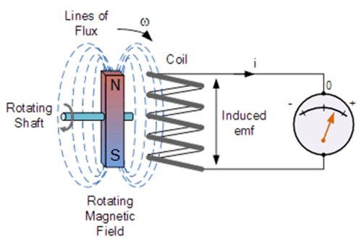

Figure3. Induced EMF

The working of the system is as followed:

- The input for system is wind velocity which tends to rotate the air ventilator.
- The rotor of generator which is of permanent magnet type rotates along with the ventilator.
- The flux of rotor cuts the stator winding and induce voltage according to the faradays law of electromagnetic induction.
- The generated electricity is taken from stator (armature windings) to power converter which includes converting ac into dc through rectifier circuit.
- The electricity is now fed to the load to be operated.
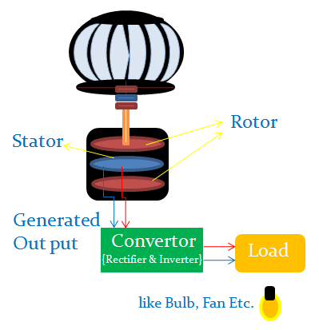

Figure4. Working diagram of air ventilator
2.2.2 Solar:
Electricity generation by solar panel include solar panels (190 Watt), solar charger, inverter, battery and load.

The working of the system is as follows:

- The solar panels convert the heat energy from sun into electrical energy.
- The output from solar panel is now fed to two parallel connected 6Amp solar chargers which make the output stable enough to charge the battery.
- The output from solar charger is now fed into 80Ah battery to charge the battery.
- The battery output is now fed into inverter for converting dc into ac which can be used for operating ac load ex. Fan, Led’s etc.

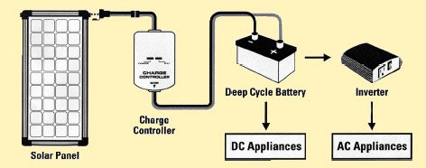

Figure5. Solar panel and battery arrangement

Chapter 3. Block diagram and working of electronic monitoring circuitry

3.1 Detailed block diagram of electronic circuitry:

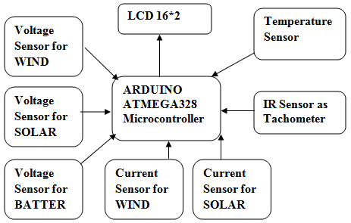

Figure6. Block diagram

Energy parameters like current, voltage & some physical parameters like RPM & temperature were real time monitored using arduino with lcd display (16*2)

3.2 Working of electronic monitoring circuitry

The sensors like temperature, current & voltage are connected through arduino which give temperature signal, current & voltage signal to arduino respectively which calculate and display the values on lcd. IR sensor is used as a tachometer which is also connected to arduino and arduino counts the interrupts by the IR sensor in one minute and displays the RPM of ventilator.

Chapter 4. Components used (Air ventilator)

4.1 Air ventilator

Ventilation is mainly used to control indoor air quality by diluting and displacing indoor pollutants; it can also be used for purposes of thermal comfort or dehumidification when the introduction of outside air will help to achieve desired indoor psychometric conditions. Nowadays, the world is talking about the green energy that can save the world from pollutions and green house effects.
The main function of the free spinning roof ventilator is to provide fresh air in roof space and living area all year round 24 hours a day free of charge. The additional function of this product is to produce the electrical energy from the roof ventilator that will spin when the wind exist. The consumers not just can enjoy the benefits of the better air ventilation in the house, but also have extra electricity supply for load appliances such as radio, mobile phone charger and aquarium oxygen pump.
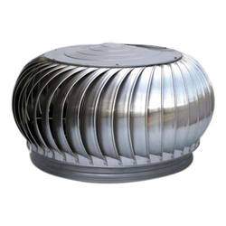

Figure7. Air ventilator

S.no. | Parameter | Value/type
1 | Base ring diameter | 24 inch
2 | Internal diameter of ventilator | 32 inch
3 | Height of ventilator | 14 inch
4 | Aluminum rods of base ring | 6mm-8mm
5 | Type of blades | Aluminum
6 | Shaft height | 14 inch

Table1. Ventilator modified specifications

4.2 Pancake type generator
In electricity generation, a generator is a device that converts mechanical energy to electrical energy for use in an external circuit. The source of mechanical energy may vary widely from a hand crank to an internal combustion engine. Generators provide nearly all of the power for electric power grids.

In our project we are using a pancake type DC generator whose stator comprises of armature winding and rotor comprises of permanent magnet.

The first step in the design was selecting the generator type. Another consideration for the generator type was whether to build a radial flux, or axial flux PMG. The radial flux would have required many concentric cylindrical parts, a cylindrical casing, cylindrical magnets, rotor etc. In an axial flux generator, also known as a pancake generator, the rotor is a flat disk of magnets which rotates on a shaft above a flat ring of stator coils. In analyzing the two design types, an axial flux PMG was chosen as our final design choice for reasons of simplicity, ease of manufacturing and cost of materials.

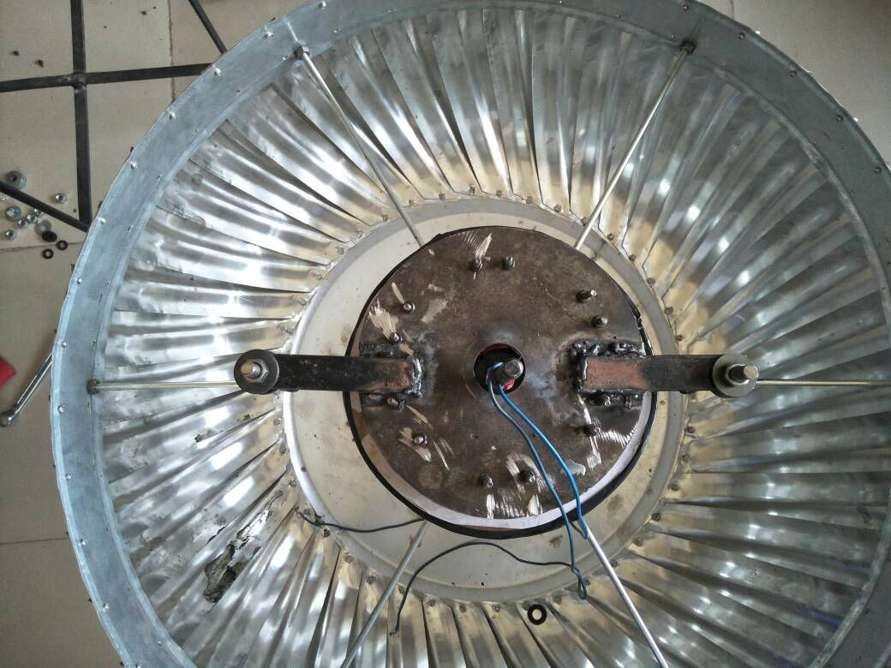

Figure8. Top view of generator

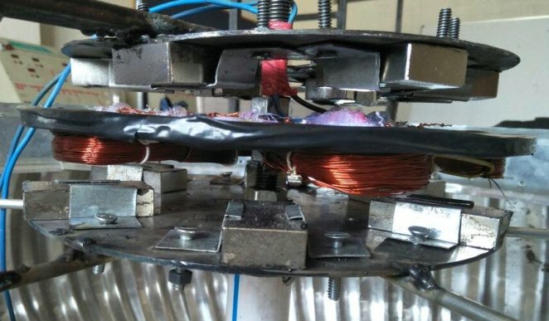

Figure9. Side view of generator

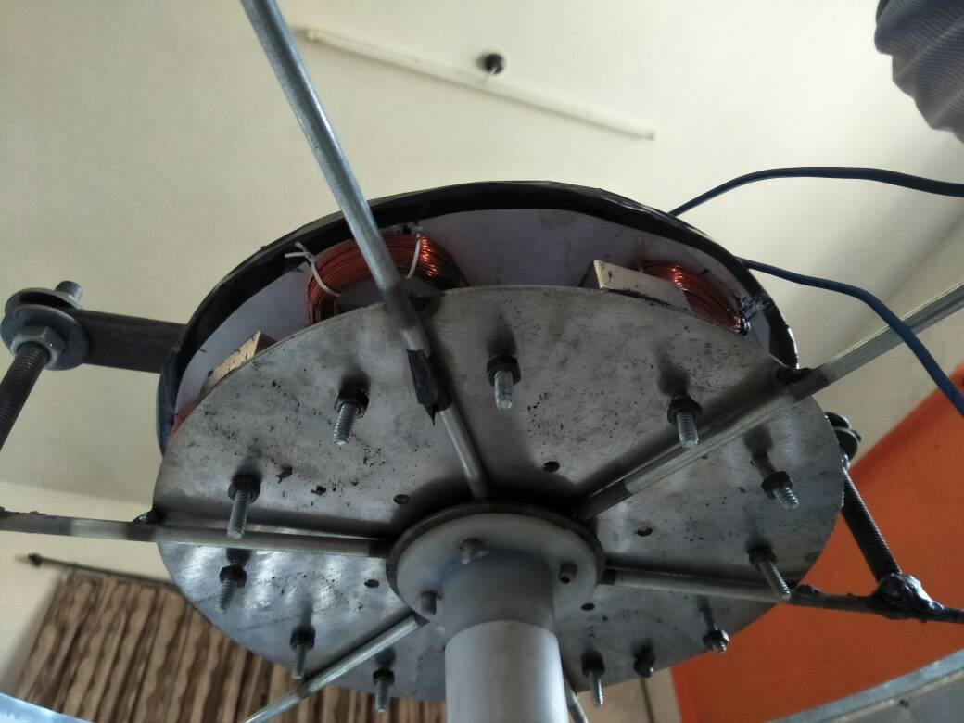

Figure10. Bottom view of generator

The alternating magnetic field from the rotor induces a voltage in the coils of the stator. The higher the number of turns in the coils, the higher the voltage that will be induced. Also, the closer the magnets are to the coils, the higher the voltage that will be induced. Magnetic flux density drops off with the square of the distance, so it is important to reduce the air gap between stator and rotor for better efficiency. And finally, the faster the rotor spins, the faster the magnetic fields are switched, the higher the voltage that will be induced. Voltage is a function of speed, while current is a function of torque. Efficiency is affected by the weight of the rotor and shaft, as well as the resistive losses in the copper coils, the frictional losses in the bearings. These are the basics of axial flux PMG operation. ^{[7]} The maximum RPM is 885 with maximum voltage of 18.5 Volt.
S.no | Parameter | Value
1. | Generated voltage | 18.5Volt
2. | Generated current | 500mA
3. | Air gap between 2 rotor discs | 20mm
4. | Air gap between stator and rotor | 7mm
5. | Type of generator | Pancake type

Table2. Generator detailed specification
4.2.1 PM disk or Rotor
in an axial flux PMG, there is a rotor mounted with a ring of magnets. The rotor is connected to the generator shaft which is driven by wind speed. The magnets on the rotor are arranged so that alternating north and south poles are perpendicular to the rotors flat top and bottom
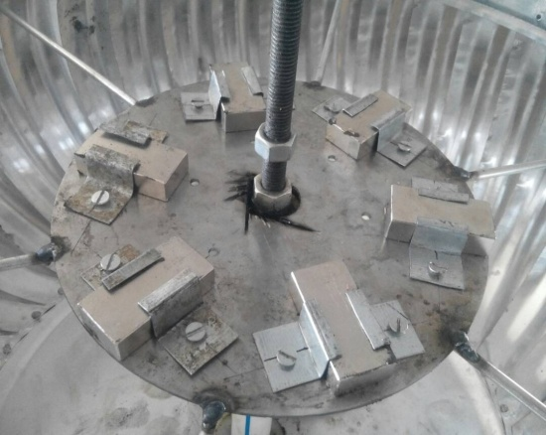
faces. The rotation of the rotor causes an alternating magnetic field at a given point above or below the rotor. In our design, we have the stator ring, a flat plate, with a ring of copper coils situated below the rotor.

Figure11. Rotor

S.no. | Parameters | Value
1 | Number of poles | 6
2 | Disc diameter | 10 inch
3 | Magnet type(Grade) | N52
4 | Size(L*W*H) | 50*25*12mm
5 | Field strength | 2.5Wb/m²

Table3. Rotor specifications
4.2.2 Stator
Stator is a static part of generator the armature winding of a Generator is almost invariably on the stator. The field winding is usually on the rotor and excited by dc current, or permanent magnets.
The stator in our pancake type generator consists of 6 coils each having 230 turns in it with a coil span of 5cm.

1. Armature windings: The armature winding is the main current-carrying winding in which the electromotive force (emf) or counter-emf of rotation is induced. The current in the armature winding is known as the armature current.
2. Field windings: The field winding produces the magnetic field in the machine. The current in the field winding is known as the field or exciting current.

In our case we have kept armature winding stationary and magnetic field is produced by neodymium magnets.

3. Concentrated winding: As name suggest, all conductor are concentrated in one slot under a pole. If there is only one slot available for winding under one pole. In very short, if slot = no. of pole, called concentrated winding.
4. Distributed winding: If no. of slot is more than no. of pole. Means, winding is distributed in many slot under a pole.
Varnish is also used to keep the windings voids away and for proper insulation.
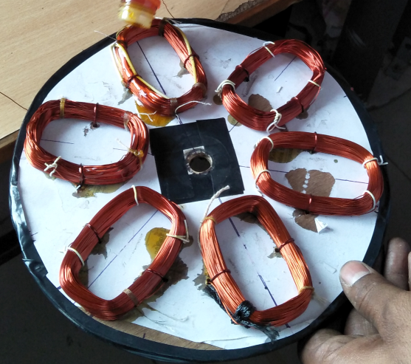

Figure12. Stator

S.no | Parameter | Value
1 | Number of coils | 6
2 | Number of turns per coil | 230
3 | Coil span | 75mm
4 | Disc diameter | 10inch
5 | Wire gauge | 26

Table4. Stator specifications

4.3 Rectifier

A full Bridge rectifier is an Alternating Current (AC) to Direct Current (DC) converter that rectifies mains AC input to DC output. Bridge Rectifiers are widely used in power supplies that provide necessary DC voltage for the electronic components or devices. They can be constructed with four or more diodes or any other controlled solid state switches.
Here full bridge rectifier is a type of single phase rectifier uses four individual rectifying diodes connected in a closed loop “bridge” configuration to produce the desired output. The main advantage of this bridge circuit is that it does not require a special centre tapped transformer, thereby reducing its size and cost. The single secondary winding is connected to one side of the diode bridge network and the load to the other side as shown below.
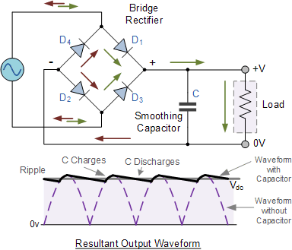

Figure13. Full bridge rectifier

The four diodes labeled D₁ to D₄ are arranged in “series pairs” with only two diodes conducting current during each half cycle. During the positive half cycle of the supply, diodes D1 and D2 conduct in series while diodes D3 and D4 are reverse biased and the current flows through the load as shown below.

Filter Capacitor: The filter capacitor increases its average DC output level even higher by connecting a suitable smoothing capacitor across the output of the bridge circuit as shown above. The smoothing capacitor converts the full-wave rippled output of the rectifier into a smooth DC output voltage. Generally for DC power supply circuits the smoothing capacitor is an Aluminum Electrolytic type that has a capacitance value of 1000uF or more with repeated DC voltage pulses from the rectifier charging up the capacitor to peak voltage.

4.4 DC appliances: These are DC devices which are installed at house, malls, offices, etc. for human comfort. Here we discussed two main DC appliances i.e. Fan & LED bulb which is mainly used: We are using Led lights of

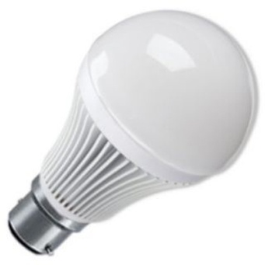

Figure14. Led bulb

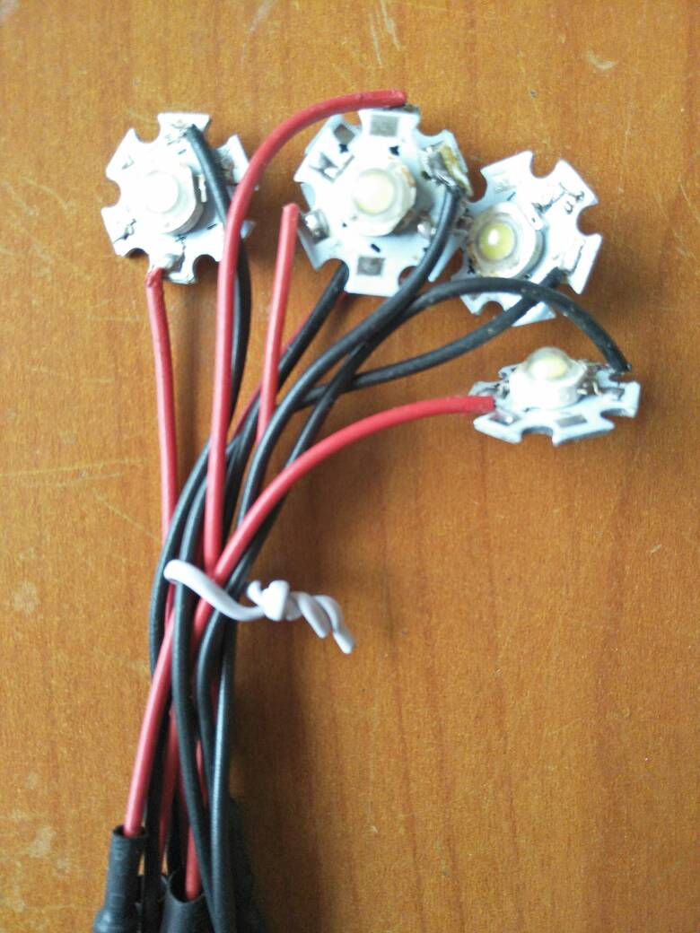

Figure15. Led array

Chapter 5. Components used (Solar panels)

5.1 Solar panels: Solar power is the conversion of energy from sunlight into electricity, either directly using photovoltaic (PV), or indirectly using concentrated solar power. Concentrated solar power systems use lenses or mirrors and tracking systems to focus a large area of sunlight into a small beam. Photovoltaic cells convert light into an electric current using the photovoltaic effect.^{[9]}
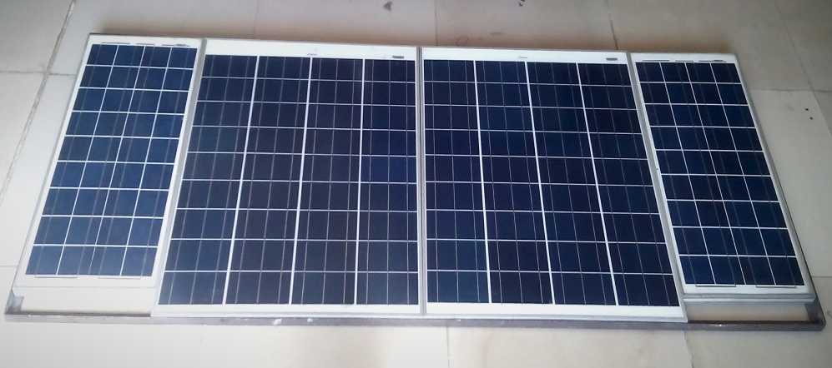

Figure16. Actual image of 190watt solar panels

The connections of solar panels are done in parallel i.e. connecting a 75W and 20W in parallel. When connections are done in parallel the voltage remains same but the current adds up.

Panel Rating | Current(Amp) | Voltage(Volts) | Total
75 watt | 4.85 | 20 | 20V
20 watt | 1.65 | 20 | 6.5Amp

Table5. Solar connections voltage and current details

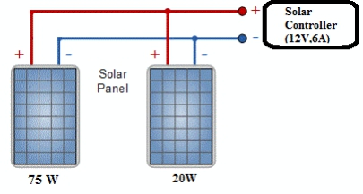

Figure17. Solar connections in parallel

5.2 Solar charge controller

A charge controller, charge regulator or battery regulator limits the rate at which electric current is added to or drawn from electric batteries. It prevents overcharging and may protect against overvoltage, which can reduce battery performance or lifespan, and may pose a safety risk.
The two solar controllers of 6Amp are used to control two panels each of 95Watt and it can be used up to 120 watt 6 Amp.

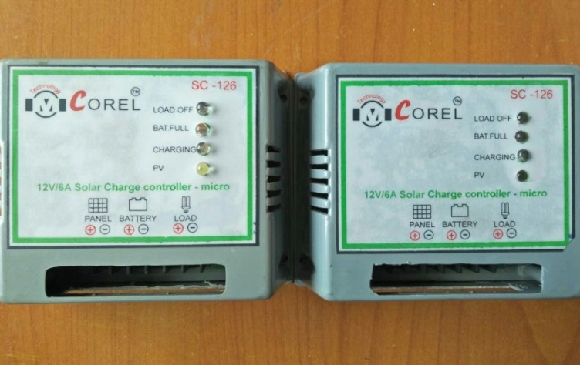

Figure18. Solar charge controller each of 6Amp

5.3 Battery ^{[10]}

The lead-acid battery has a very low energy-to-weight ratio and a low energy-to-volume ratio, its ability to supply high surge currents means that the cells have a relatively large power-to-weight ratio. These features, along with their low cost, makes it attractive for use in motor vehicles to provide the high current required by automobile starter motors.
The battery ratings are as such:
Lead acid battery 12V,80Ah.

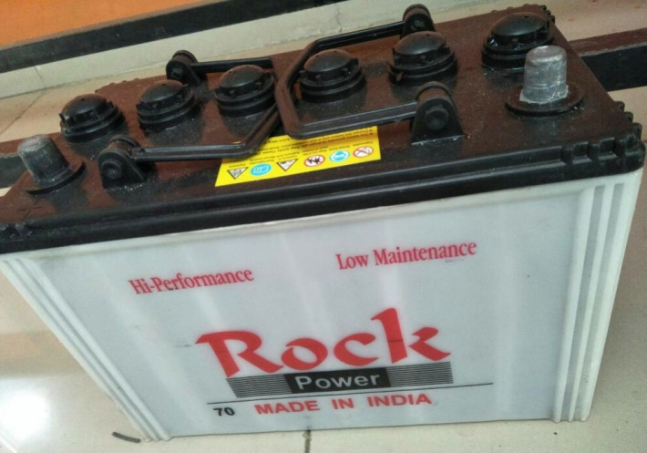

Figure19. 12V, 80 Ah batteries

5.4 Inverter

A power inverter, or inverter, is an electronic device or circuitry that changes direct current (DC) to alternating current (AC).
The input voltage, output voltage and frequency, and overall power handling depend on the design of the specific device or circuitry. The inverter does not produce any power; the power is provided by the DC source.

The microtek inverter converts the input power (dc) coming from12V, 80Ah battery and powers the ac load like led bulbs and fan.
Power rating: 900VA
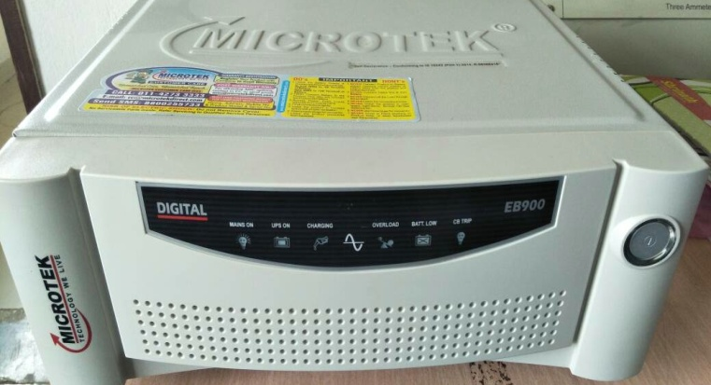

Figure20. 900VA inverter

5.5 AC load

An electrical load is an electrical component or portion of a circuit that consumes electric power. This gets supply by a power source, such as a battery or generator, which produces power. In electric power circuits examples of loads are appliances and lights. The term may also refer to the power consumed by a circuit.

AC appliances: These are AC devices which are installed at house, malls, offices, etc. for human comfort. Here we discussed two main AC appliances i.e. Fan & CFL bulb which are mainly used.

Ceiling Fan: A ceiling fan is a mechanical fan, usually electrically powered, suspended from the ceiling of a room, that uses hub-mounted rotating paddles to circulate air.

Chapter 6. Components used in electronic controller circuitry

6.1 Arduino uno: Arduino Uno is a microcontroller board based on the ATmega328P (datasheet). It has 14 digital input/output pins (of which 6 can be used as PWM outputs), 6 analog inputs, a 16 MHz quartz crystal, a USB connection, a power jack, an ICSP header and a reset button. It contains everything needed to support the microcontroller; simply connect it to a computer with a USB cable or power it with a AC-to-DC adapter or battery to get started..
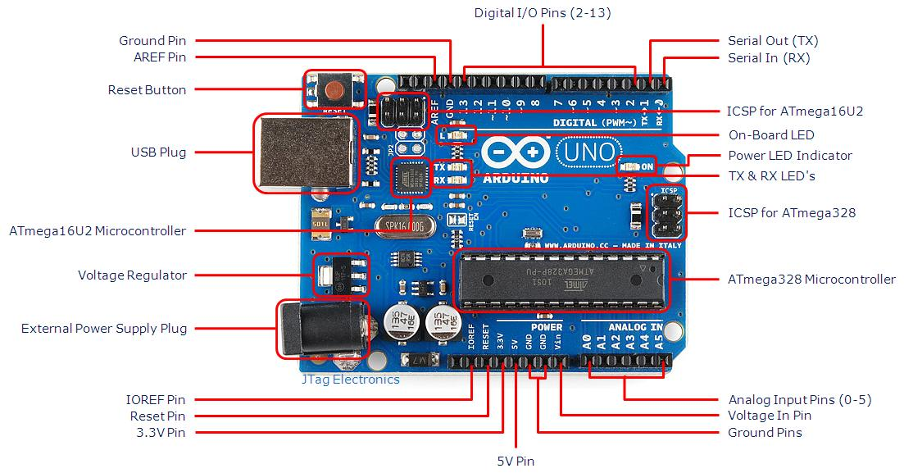

Figure21. Detailed diagram of arduino

1 Power USB
Arduino board can be powered by using the USB cable from your computer. All you need to do is connect the USB cable to the USB connection 11.

2 Power BarrelJack
Arduino boards can be powered directly from the AC mains power supply by connecting it to the Barrel Jack 22.

3 Voltage Regulators
The function of the voltage regulator is to control the voltage given to the Arduino board and stabilize the DC voltages used by the processor and other elements.

4Crystal Oscillator
The crystal oscillator helps Arduino in dealing with time issues. How does Arduino calculate time? The answer is, by using the crystal oscillator. The number printed on top of the Arduino crystal is 16.000Hz. It tells us that the frequency is 16,000,000 Hertz or 16 MHz.

5, 17 Arduino Reset
You can reset your Arduino board, i.e., start your program from the beginning. You can reset the UNO board in two ways. First, by using the reset button 1717 on the board. Second, you can connect an external reset button to the Arduino pin labelled RESET 55.
Pins 3.3, 5, GND, Vin3.3, 5, GND, Vin
3.3V 66 − Supply 3.3 output volt
5V 77 − Supply 5 output volt

6,7,8,9 Most of the components used with Arduino board works fine with 3.3 volt and 5 volt.
GND 88GroundGround − There are several GND pins on the Arduino, any of which can be used to ground your circuit.
Vin 99 − This pin also can be used to power the Arduino board from an external power source, like AC mains power supply.

10 Analog pins
The Arduino UNO board has five analog input pins A0 through A5. These pins can read the signal from an analog sensor like the humidity sensor or temperature sensor and convert it into a digital value that can be read by the microprocessor.

11 Main microcontroller
Each Arduino board has its own microcontroller 1111. You can assume it as the brain of your board. The main IC integrated circuit on the Arduino is slightly different from board to board. The microcontrollers are usually of the ATMEL Company. You must know what IC your board has before loading up a new program from the Arduino IDE. This information is available on the top of the IC. For more details about the IC construction and functions, you can refer to the data sheet.

12 ICSP pin
Mostly, ICSP 1212 is an AVR, a tiny programming header for the Arduino consisting of MOSI, MISO, SCK, RESET, VCC, and GND. It is often referred to as an SPI Serial Peripheral Interface, which could be considered as an "expansion" of the output. Actually, you are slaving the output device to the master of the SPI bus.

13 Power LED indicator
This LED should light up when you plug your Arduino into a power source to indicate that your board is powered up correctly. If this light does not turn on, then there is something wrong with the connection.

14 TX and RX LEDs
On your board, you will find two labels: TX transmit and RX receive. They appear in two places on the Arduino UNO board. First, at the digital pins 0 and 1, to indicate the pins responsible for serial communication. Second, the TX and RX led 1313. The TX led flashes with different speed while sending the serial data. The speed of flashing depends on the baud rate used by the board. RX flashes during the receiving process.

15 Digital I/O
The Arduino UNO board has 14 digital I/O pins 1515 of which 6 provide PW M(PulseWidthModulation) output. These pins can be configured to work as input digital pins to read logic values 0or10or1 or as digital output pins to drive different modules like LEDs, relays, etc. The pins labeled “~” can be used to generate PWM.
16 AREF
AREF stands for Analog Reference. It is sometimes, used to set an external reference voltage between0and5Voltsbetween0and5Volts as the upper limit for the analog input pins.

Technical specs
Microcontroller | ATmega328P
Operating Voltage | 5V
Input Voltage (recommended) | 7-12V
Input Voltage (limit) | 6-20V
Digital I/O Pins | 14 (of which 6 provide PWM output)
PWM Digital I/O Pins | 6
Analog Input Pins | 6
DC Current per I/O Pin | 20 mA
DC Current for 3.3V Pin | 50 mA
Flash Memory | 32 KB (ATmega328P)  of which 0.5 KB used by bootloader
SRAM | 2 KB (ATmega328P)
EEPROM | 1 KB (ATmega328P)
Clock Speed | 16 MHz
LED_BUILTIN | 13
Length | 68.6 mm
Width | 53.4 mm
Weight | 25 g

Table6. Technical specifications (Arduino)
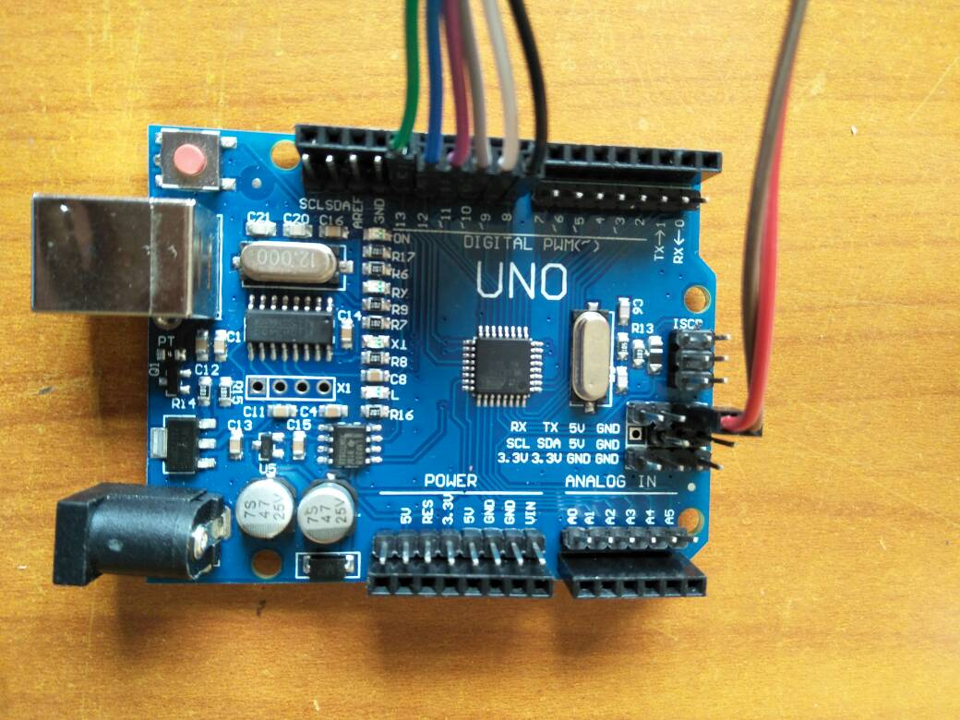

Figure22. Arduino uno

6.2 Temperature sensor: LM35 is a precision IC temperature sensor with its output proportional to the temperature (in ºC). The sensor circuitry is sealed and therefore it is not subjected to oxidation and other processes. With LM35, temperature can be measured more accurately than with a thermistor. It also possess low self heating and does not cause more than 0.1 ºC temperature rise in still air.
The operating temperature range is from -55°C to 150°C. The output voltage varies by 10mV in response to every ºC rise/fall in ambient temperature, i.e., its scale factor is 0.01V/ ºC.

6.3 IR sensor as tachometer: Tachometer is a device used for measuring the number of revolutions of an object in a given interval of time. Usually it is expressed in revolutions per minute or RPM. The rpm is determined using a gear mechanism and it is displayed on a dial. The RPM and all the other information is displayed on a 16×2 LCD screen. The circuit diagram of the digital tachometer using arduino is shown below.

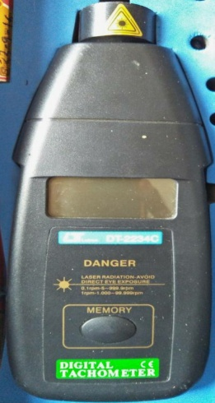

Figure23. Tachometer

Counting the RPM.

Arduino is used for counting the RPM and displaying it on the LCD screen. Emitter of the photo transistor is connected to the Interrupt 0 (digital pin 2) of the arduino. The arduino interrupt is configured to be rising edge triggered. As a result the will be an interrupt for every upward shoot in the emitter waveform. The number of interrupts occurred in a given time is counted by incrementing a varible using the interrupt service routine. The time elapsed during te counting cycle is determined using the millis() function. The millis() function returns the number of milli seconds passed since the arduino board is switched ON. Calling the millis() function before and after the counting cycle and the taking their difference gives the times passed during the counting cycle. The (number of interrupts/time in milliseconds)*60000 will give the revolutions per minute (RPM).

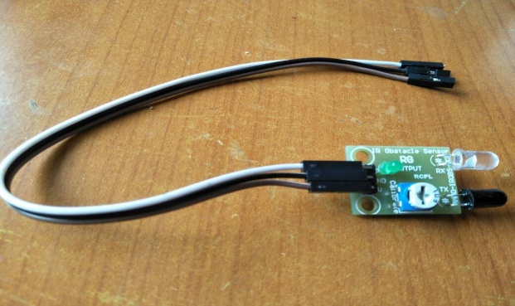

Figure24. IR sensor as tachometer

6.4 Voltage Sensor: It is a simple digital voltmeter, which can safely measure input dc voltages in 0 to 30V range As we know, Arduino’s analog inputs can be used to measure DC voltage between 0 and 5V (when using the standard 5V analog reference voltage) and this range can be increased by using two resistors to create a voltage divider. The voltage divider decreases the voltage being measured to within the range of the Arduino analog inputs. Code in the Arduino sketch is then used to compute the actual voltage being measured.

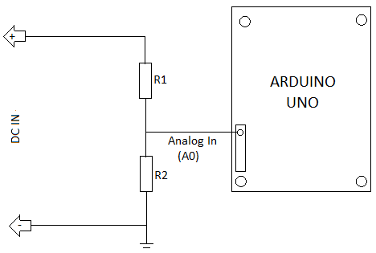

Figure25. Voltage sensor working

The analog sensor on the Arduino board senses the voltage on the analog pin and converts it into a digital format that can be processed by the microcontroller. Here, we are feeding the input voltage to the analog pin (A0) using a simple voltage divider circuit comprising resistors R1 (100K) and R2 (10K). With the values used in the voltage divider it is possible to feed voltage from 0V to 55V into the Arduino board. The junction on the voltage divider network connected to the the Arduino analog pin is equivalent to the input voltage divided by 11, so 55V ÷ 11 = 5V. In other words, when measuring 55V, the Arduino analog pin will be at its maximum voltage of 5V. So, in practice, it is better to label this voltmeter as “0-30V DVM” to add a safety margin!
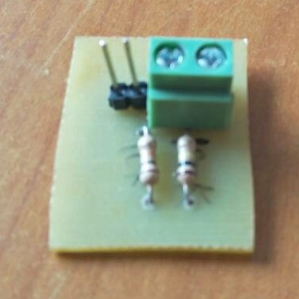

Figure26. Voltage sensor

6.5 Current Sensor: Accurate sensor to measure AC/DC current up to 20A. The sensor can even measure high AC mains current and is still isolated from the measuring part due to integrated hall sensor. The board operates on 5V.
ACS712 current sensor operates from 5V and outputs analog voltage proportional to current measured on the sensing terminals. You can simple use a microcontroller ADC to read the values.

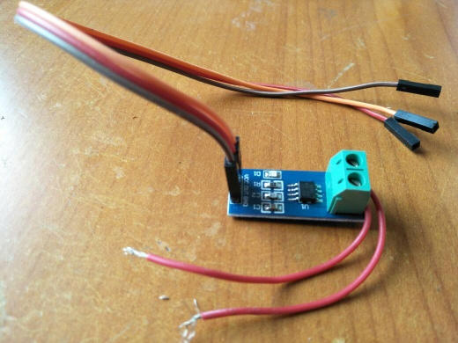

Figure27. Current sensor

6.6 LCD (liquid crystal display) 16*2:

LCD (Liquid Crystal Display) screen is an electronic display module and find a wide range of applications16×2 LCD is named so because; it has 16 Columns and 2 Rows. There are a lot of combinations available like, 8×1, 8×2, 10×2, 16×1, etc. But the most used one is the 16*2 LCD, hence we are using it here.
All the above mentioned LCD display will have 16 Pins and the programming approach is also the same and hence the choice is left to you.
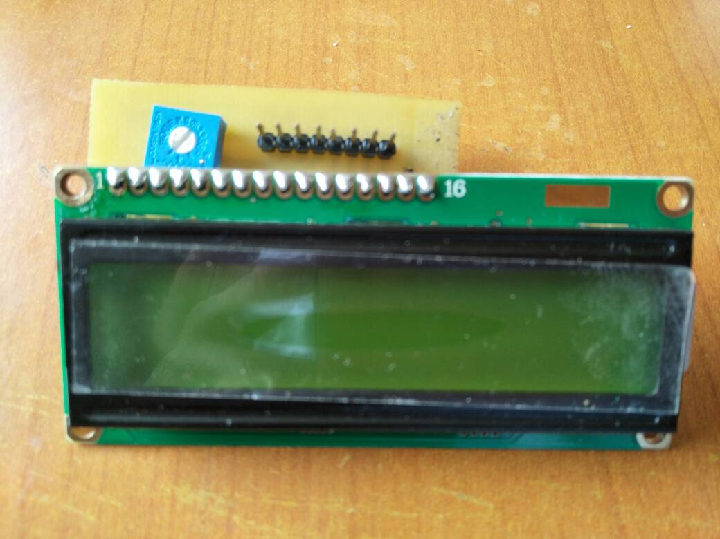

Figur28. LCD display

6.7 Arduino Software: The Arduino software is open-source. The source code for the Java environment is released under the GPL and the C/C++ microcontroller libraries are under the LGPL.

The program of the circuitry is given below:

#include <LiquidCrystal.h> // include the library code:
LiquidCrystal lcd(8,9,10,11,12,13); // initialize the library with the numbers of the interface pins

//Voltmeter Variables

float voutw=0.0;
float vouts=0.0;
float voutb=0.0;
float vinw=0.0;
float vins=0.0;
float vinb=0.0;
float R1 = 100000.0; // resistance of R1 (100K) -see text!
float R2 = 10000.0; // resistance of R2 (10K) - see text!
int valw=0;
int vals=0;
int valb=0;

//RPM Variables
float value=0;
float rev=0;
int rpm;
int oldtime=0;
int time;

void isr() //interrupt service routine
{
rev++;
}

//Temperature Variables

int itemp; // define variables for ADC count, actual voltage measured in mV and actual temperature
float ftemp,fcelsius;

void setup()
{
// set up the LCD's number of rows and columns:
lcd.begin(16, 2);
// Print a message to the LCD.
lcd.setCursor(0, 0);
lcd.print("GENERATOR");
lcd.setCursor(0,1);
lcd.print("ELECTRICAL DEPT.");
delay(1000);

//Rpm setup
attachInterrupt(0,isr,RISING); //attaching the interrupt
}// end of setup.

Void loop ()
{
//TEMPERATURE
// read the adc count in var i.
itemp = analogRead(A0);// note itemp is an int and may have a range of 0 to 1023.
ftemp = ((5000.0 * itemp) / 1024.0);// voltage in millivolts converted. Decimal point promotes or converts int into float.
fcelsius = (ftemp / 10.0) ;// convert voltage into temperature into degree Celcious.

// RPM Measurement
delay(1000);
detachInterrupt(0); //detaches the interrupt
time=millis()-oldtime; //finds the time
rpm=((rev/time)*60000); //calculates rpm
oldtime=millis(); //saves the current time
rev=0;
attachInterrupt(0,isr,RISING);

//Voltmeter WIND
valw = analogRead(A1);
voutw = (valw * 4.84) / 1024.0; // see text
vinw = voutw / (R2/(R1+R2));

//Voltmeter SOLAR
vals = analogRead(A2);
vouts = (vals * 4.84) / 1024.0; // see text
vins = vouts / (R2/(R1+R2));

//Voltmeter BATTERY
valb = analogRead(A3);
voutb = (valb * 4.84) / 1024.0; // see text
vinb = voutb / (R2/(R1+R2));

//Ammeter WIND
float Waverage = 0;
for(int i = 0; i<1000; i++)
{
Waverage = Waverage + (0.000049 * analogRead(A4) -0.025);
delay(1);
}

//Ammeter SOLAR
float Saverage = 0;
for(int i = 0; i<1000; i++)
{
Saverage = Saverage + (0.000049 * analogRead(A5) -0.025);
delay(1);

// so we will format LCD message appropriately
lcd.clear();
lcd.setCursor(0, 0);
lcd.print("Temp=");// message squeezed in 16 char
lcd.print(fcelsius);
lcd.setCursor(0,1);// position the cursor on column 0 in bottom row
lcd.print("RPM=");
lcd.print(rpm);
delay(4000);

////voltage print
lcd.clear();
lcd.setCursor(0, 0);
lcd.print("Vw=");
lcd.print(vinw);

lcd.setCursor(9,0);
lcd.print("Vs=");
lcd.print(vins);

lcd.setCursor(0, 1);
lcd.print("Vb=");
lcd.print(vinb);
delay(4000);

//curent print
lcd.clear();
lcd.setCursor(0, 0);
lcd.print("Iw=");
lcd.print(Waverage);

lcd.setCursor(0,1);
lcd.print("Is=");
lcd.print(Saverage);
delay(4000);

Project Images

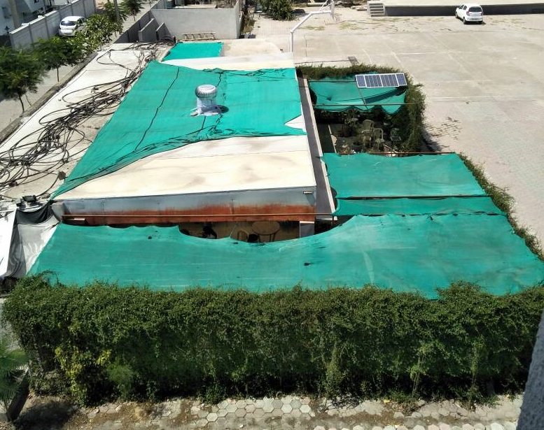

Chapter 7. Advantages and applications

- Air ventilators can be used to ventilate inside air as well as generate electricity.
- Since ventilators are in work for 24 hours therefore it can generate electricity even in night hours.
- Ventilators can charge the battery during night hours.
- Can be used for light loads such as mobile charger, Led bulbs etc.
- Can be used in institutions where temperature ranges are within limit like below 80°C as air ventilators are the need of today’s scenario.
- Solar panel reduces electricity bills.
- Solar panels have low maintenance cost.
- Uses clean energy as the source of generation.
- Low operation cost.
- Absolute safe even for domestic purpose.
- Since the energy demand of the world is rising, therefore it can be further used for generation of renewable energy.

Chapter 8. Future Scope

This project demonstrated that it is possible to build a prototype air ventilator generator on a minimum budget. The project mainly aims to generate electricity with this type of model which can be successfully generated. The efficiency of the generator can be further improved in near future by bringing modifications in ventilator speed through some mechanical variations like blades shape etc., also the emf generation can be increased by using better and lighter magnets and better winding calculations in coming future. The output voltage and power can be immensely increased by bringing some modifications in windings and proper assembling of the generator. Since we have collaborated solar therefore the project totally uses renewable energy as a source of electricity generation which goes well with clean and efficient energy production, which is the need in today’s world. Once the concept of generation gets highlighted by this project the project can even get patent and serve multiple companies and industries in near future for a better and sustainable tomorrow.

9. Conclusion

The entire literature survey has been completed by thoroughly studying various research papers and articles. The project has led us a complete study of generators and air ventilator which has cleared our basic concepts of electrical energy. With our project we have also done some major modifications like making Pancake motor a generator and replacing rotator winding with stationary part. We have made the magnets rotor by selecting high grade neodymium magnets in our project. With maximum hit and trial methods applied we have also used different gauges of winding for maximum output and using various electronic items like buck and boost converter, voltage doubler which though we haven’t used due to its limitations but we came to know about their working and standards. Apart from learning our major project also led all our group members to work in a team with unity. With purchasing of project products we learned buying and interacting with retailers i.e. how to deal with shopkeepers. The entire major project has led us a complete learning from minute to bigger aspects of life which will count in our experience throughout our life. The overall project including air ventilator and solar has been completed successfully with detailed study and implementation.

10. References

[1] “Design of the coreless axial-flux double sided permanent magnet synchronous generator for wind power system”, International journal of scientific engineering and technology research volume.03, issueNo.10, May-2014.
[2] Akshay.S.Zagade, Rahul.P.Sadagar, Electric power generation by using rooftop turbine ventilator, International Journal of Current Trends in Engineering & Research (IJCTER) e-ISSN 2455–1392 Volume 2 Issue 4, April 2016 pp. 474 – 480
[3] https://en.wikipedia.org/wiki/Electricity_sector_in_India#cite_note-17
[4] http://www.sciencedirect.com/science/article/pii/S1364032116000770
[5] http://vishwasengineering.com/product.html
[6] Nick bannon, Jimmy davis & Erin clement, Axial Flux Permanent Magnet Generator, UW
ME, University of Washington [7] https://en.wikipedia.org/wiki/Neodymium_magnet#cite_note-MagnetGradeChart-15
[8] Full Wave Rectifier and Bridge Rectifier Theory
http://www.electronics-tutorials.ws/diode/diode_6.html
[9] https://en.wikipedia.org/wiki/Solar_power
[10] https://en.wikipedia.org/wiki/Lead%E2%80%93acid_battery

